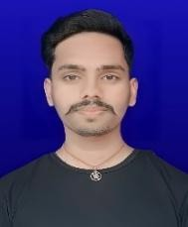
RESUME
Abhishek Kumar
+91 9262768085
abhishekdatapur@gmail.com

OBJECTIVE
To secure a challenging role in a reputable organization where I can utilize my technical skills, problem-solving abilities, and strong work ethic to contribute to the growth and success of the company.

EDUCATION

DEGREE/COURSE | UNIVERSITY/BOARD | PASSING YEAR | DIVISION | PERCENTAGE
UG | Maa Shakumbhari University | Pursuing
12th | BSEB Patna | 2023 | 1st | 67.8%
10th | BSEB Patna | 2021 | 1st | 72.4%

SKILLS
- HTML
- CSS
- Javascript
- C++
- OOPs (C++)
- DSA
- Adobe Photoshop

HOBBIES
- Reading Books
- Honest & Punctual
- Good Communication

PERSONAL DETAILS
Father’s Name : Devendra Ram Mother’s Name : Manju Devi Date of Birth : 07-12-2004
Address : At- Datapur, Post- Basantpur Patti,
Police Station- Saraiya, District- Muzaffarpur, Bihar, 843101

Nationality : Indian
Religion : Hindu
Gender : Male
Marital Status : Unmarried

LANGUAGE KNOWN
- Hindi
- English

DECLARATION
Declared that all the information furnished above is true and correct to the best of my knowledge and belief.

Place………………………
Date……………………… Abhishek Kumar

